Cole Nielsen

LA 1201

Exercise 4

TA: Rachel Kerber

For this assignment I reread Anne Whiston Spirn’s “Ecological Urbanism: A Framework for the Design of Resilient Cities”. From the reading, it is apparent that Spirn’s number one value regarding city landscapes is that they are all part of natural world and must be designed in harmony with nature rather than at odds with it. What Spirn means by a city is part of the natural world is the notion that a city is undoubtedly part of nature, as it interacts with water, air and energy flow, as well as it is the habitat of organisms like humans and affects the ecology of the landscape. Because of the city is part of nature, it can have a positive or negative impact on the natural ecosystem of the landscape it occupies, and for the health of the habitats it is important that the impact be good. It also follows that as a part of nature, if a city ignores the features and processes of nature, such ignoring erosion, harmful consequences can follow, harming the cities inhabitants. Therefore, it follows that Spirn’s notion that a city be cultivated in touch with nature for the wellbeing of its inhabitants and the ecosystem as a whole. This idea goes against the old notion that cities are the antithesis of nature used in during the time of construction of cities like NYC, which has cultivated those cities to have ecological problems like pollution, flooding and general inefficiencies that make them poor habitats for humans and inhabitable for most other organisms. Another value that Spirn has regarding the city as a landscape is that it is dynamic – that it changes over time- especially in regards to the natural habitat. She argues that because it is dynamic, the urban landscape of a city must be designed to facilitate the foreseeable change (an example could be change in waterfronts of a river as it erodes away a river basin) to ensure sustainability of the landscape in the future. Altogether, Spirn calls these notions of ecological consideration in an urban landscape “Eco-Urbanism”.

In the scope of a city neighborhood, Anne Spirn would likely look at several things through her lens of eco-urbanism. The most important aspect I think she would look at is how well the neighborhood is integrated into the natural environment that surrounds it. One could tell this by looking at aspects like how well water can drain out of the area into the natural watershed (so exposed earth rather than all concrete), how well the flora and fauna of the area blends with that naturally found in the area and the living conditions of the inhabitants. I think she would also look to see how sustainable the landscape appears to be in terms of the city being a dynamic ecosystem, factoring in foreseeable natural changes like erosion as well as human changes in population and use of the land. A third thing I think she would look at is how well the landscape is formed in respect to the context, or essentially its predispositions like climate, location, and the nature of its population in terms of development and distribution.

Spirn’s view on urban landscapes is what I think to be similar, yet different on several different issues to that of Ian McHarg and Kevin Lynch. All three seem to have shared a belief that the natural environment has some value in the design of urban landscapes, but exactly why is how they all differ. In the case of Ian McHarg, he believed that nature is a systematic set of processes that follow laws (the laws of nature), and that these processes can be classified into different categories like climate, geology, hydrology and so on. He was a firm believer that a landscape could be essentially be surveyed for and described for each of those categories, and that information could be used as insight into the landscape such as its values, opportunities and issues so that the land could be best utilized for man. So in a sense McHarg saw the natural landscapes in a very scientific way, and they were evolved (adapted) from the natural landscape into something that man can use such as urban landscapes, which differs from Spirn seeing a landscape as a continual and eternal part of the ecosystem. His views are similar to Spirn’s as they both advocate the GIS type approach to analyzing land to best utilize it, however they differ in regard like McHarg viewed landscape with a very rigid dichotomy that really only encompassed physical things, whereas I think Spirn is more dynamic, considering things like people and history of a place. In the case of Kevin Lynch, I think his beliefs are fairly different from that of McHarg and Spirn. In particular, Lynch was a believer a city is first and foremost a human habitat, and that nature was something that could be used to enhance the habitat. I think belief sets him apart from McHarg and Spirn because he considers people first, whereas McHarg and Spirn both consider the environment/characteristics of a place first when designing a landscape. Also, Lynch believed in using the natural environment to improve to coherence and identity of a landscape in a region, so his utilization was more of nature was more of an aesthetic thing where as Spirn and McHarg used it to improve the landscape to better suit the living condition of the inhabitants.

After visiting Dinkytown, I think overall Spirn would focus on several aspects of the neighborhood, the most important one being that the neighborhood doesn’t mesh very well with the natural environment of Minnesota. The first thing that stood out upon visiting Dinkytown is that it is largely a jungle of cement and buildings, with little real natural landscape left behind, as demonstrated below in *Figure 1.*

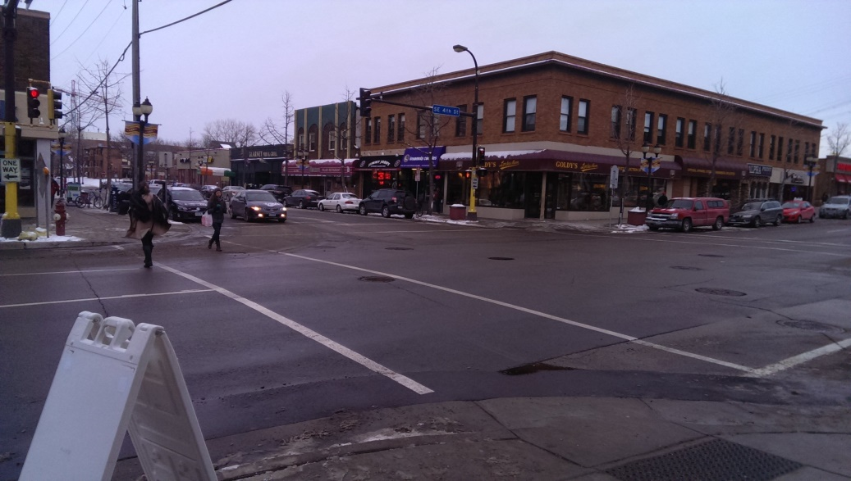

*Figure 1:* Intersection of Dinkytown largely constituted of pavement and buildings.

As visible in *Figure 1*, Dinkytown resembles little of what one would think of nature; rather it portrays an image of a highly developed urban area. Despite having a couple trees along the sidewalks, the landscape of Dinkytown in reality is largely void of nature. The only glimpse of nature to be seen is down underneath and separated from the neighborhood and interaction of people on the railroad tracks. This is shown in *Figure 2:*

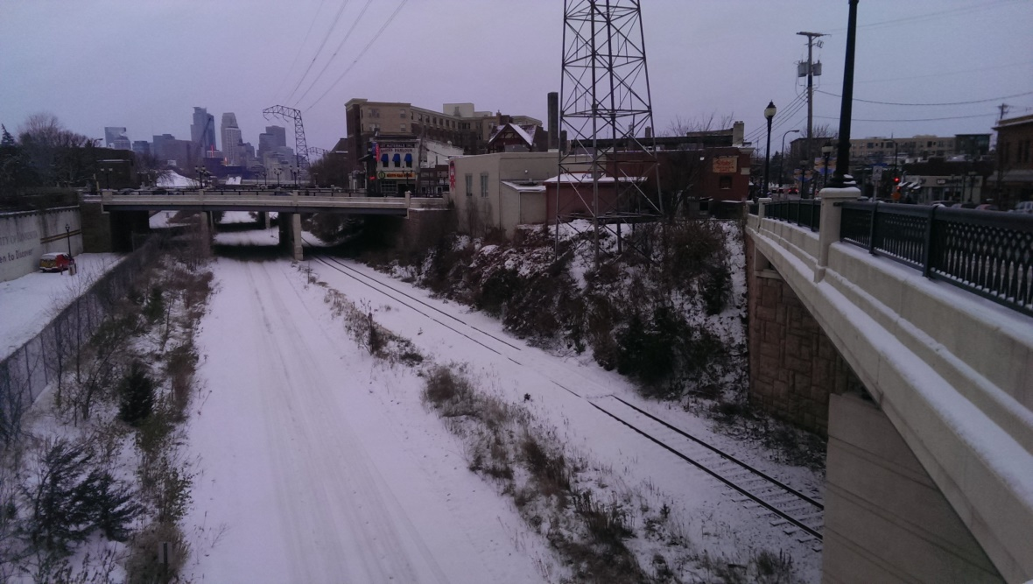

*Figure 2:* Foliage growing along the rail road tracks below Dinkytown.

Although this little strip of nature is present, it is highly isolated from the rest of Dinkytown by overpasses and physical barrier, enough that it makes the two almost separate ecosystems. This furthers the notion that the neighborhood of Dinkytown is very disconnected to the natural environment. One may wonder how the neighborhood got to be in a condition like it is, and the answer likely lies with the fact that it is a fairly old neighborhood that was constructed before eco-urbanism and even planning of landscapes based on biotic factors became an area of interest to city planners and architects. The disconnect of the area to nature can even be observed just by noting the fact that snow (a natural part of the environment) is actively removed from the streets and sidewalks as evident in the below *Figure 3.* Perhaps an environment that was built with the natural landscape in consideration would utilize designs for transport such as underground trains that require little obstruction to the natural snow fall on the landscape.

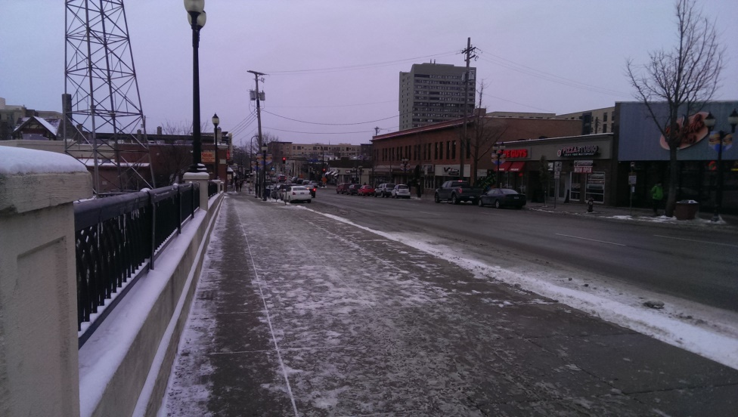

*Figure 3:* Streets and sidewalks of Dinkytown well plowed and shoveled.

Another aspect Spirn may look at in Dinkytown is the overall aesthetic generated by the natural environment deficient design of the landscape. From the view of Spirn, it is deducible that a city of good aesthetic would integrate large amounts of green space and features that integrate the natural ecosystem into the city, however little of that is to be found in Dinkytown. Rather, cement, black top, buildings and man build structures dominate the land, producing a city like aesthetic that many (and likely Spirn would) laud as “ugly”. An example from Dinkytown of not especially appealing design can be seen in the alleyway shown in *Figure 4:*

*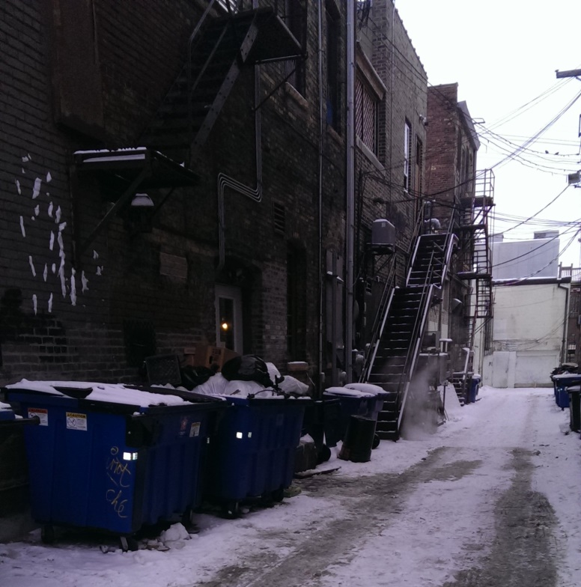*

*Figure 4:* Alleyway of Dinkytown.

This “ugly” aesthetic is characterized in the alley by dumpsters running along the length of it, giving it a dirty look, as well as the power lines, discolored buildings/run down look. This “ugly” look in the view of Spirn is seen throughout Dinkytown, like below in *Figure 5* looking down a main street of Dinkytown where we again see the power lines, eclectic, rundown and in general unappealing urban architecture that could look much better if integrated with the natural ecosystem. An example of an aesthetically “better” appearing landscape can be found just across the street from where *Figure 5* was taken in the Knoll, a part of the U campus that is characterized by large amounts of grass and trees that make the landscape feel more natural and aesthetic.

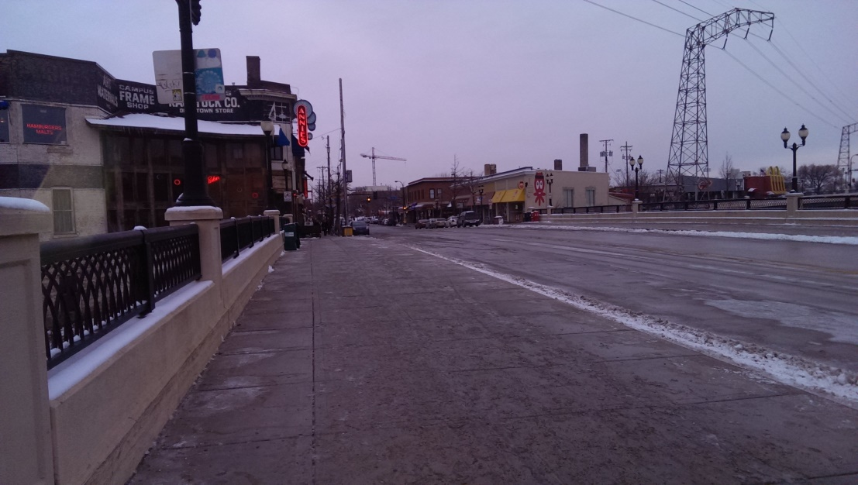

*Figure 5:* Street Running through Dinkytown.

Overall, I think Spirn would say that the neighborhood of Dinkytown is not working when looked at through the lens of eco-urbanism, primarily due to the landscape of the neighborhood subduing nature almost entirely with manmade structures. I think in order to fix this landscape in the eyes of Spirn, much of the area would have to be dramatically changed in order to integrate more green space and promote harmony with nature.